POCT试剂参数汇总
Item | Traceability | Classification | Anticoagulation | Sample Type | Amount | Measuring Range | Reference Value | Reaction Time
cTnI | Abbott | CG | Heparin, EDTA | S/P/W.B | 120 μL | 0.5-50 ng/mL | 0.5 ng/mL | 15 min
cTnI | Abbott | IF | Heparin, EDTA | S/P/W.B | 100 μL | 0.1-50 ng/mL | 0.1 ng/mL | 10 min
TnT | Roche | IF | Heparin, EDTA  Sodium citrate | S/P/W.B | 100 μL | 10-10000 pg/mL | 14 pg/mL | 15 min
CK-MB | Beckman | CG | Heparin, Sodium citrate | S/P/W.B | 120 μL | 2.5-80 ng/mL | 5.0 ng/mL | 15 min
CK-MB | Beckman | IF | Heparin, Sodium citrate | S/P/W.B | 100 μL | 2.5-80 ng/mL | 5.0 ng/mL | 10 min
BNP | Alere | IF | EDTA | P/W.B | 100 μL | 5-5000 pg/mL | 100 pg/mL | 10 min
NT-proBNP | Roche | CG | Heparin, Sodium citrate | S/P/W.B | 120 μL | 100-35000 pg/mL | 300 pg/mL | 15 min
NT-proBNP | Roche | IF | Heparin, Sodium citrate | S/P/W.B | 100 μL | 100-35000 pg/mL | 300 pg/mL | 10 min
NT-proBNP/  cTnI | Same to the single item | CG | Heparin, Sodium citrate | S/P/W.B | 120 μL | NT: 100-12000 pg/mL  cTnI: 0.5-50 ng/mL | NT: 300 pg/mL  cTnI: 0.5 ng/mL | 18 min
NT-proBNP/  cTnI | Same to the single item | IF | Heparin, EDTA | S/P/W.B | 100 μL | NT: 100-15000 pg/mL  cTnI: 0.1-50 ng/mL | NT: 300 pg/mL  cTnI: 0.1 ng/mL | 10 min
H-FABP | / | IF | Heparin, EDTA  Sodium citrate | S/P/W.B | 100 μL | 1-120 ng/mL | 95%: 3.49 ng/mL  99%: 6.36 ng/mL | 3 min
CK-MB/cTnI | Same to the single item | CG | Heparin, EDTA | S/P/W.B | 100 μL | CK-MB: 2.5-80 ng/mL  cTnI: 0.1-50 ng/mL | CK-MB: 5 ng/mL  cTnI: 0.1 ng/mL | 10 min
CK-MB/cTnI | Same to the single item | IF
CK-MB/cTnI/  H-FABP | Same to the single item | IF | Heparin, EDTA | S/P/W.B | 100 μL | CK-MB: 2.5-80 ng/mL  cTnI: 0.1-50 ng/mL  H-FABP: 2-100 ng/mL | CK-MB: 5 ng/mL  cTnI: 0.1 ng/mL  H-FABP:  95%: 3.49 ng/mL  99%: 6.36 ng/mL | 10 min
CK-MB/cTnI  /Myo | Same to the single item | CG | Heparin, EDTA | S/P/W.B | 120 μL | 2.5-80.0 ng/mL | 5.0 ng/mL | 15 min
 |  |  |  |  |  | CG: 0.5-50 ng/mL  IF: 0.1-50 ng/mL | CG: 0.5 ng/mL  IF: 0.1 ng/mL | 15 min
CK-MB/cTnI  /Myo | Same to the single item | IF | Heparin, EDTA | S/P/W.B | 100 μL | CG: 0.5-50 ng/mL  IF: 0.1-50 ng/mL | CG: 0.5 ng/mL  IF: 0.1 ng/mL | 10 min
 |  |  |  |  |  | CG: 30-1000.0 ng/mL  IF: 30-600 ng/mL | 70 ng/mL | 10 min
hs-CRP+CRP | Roche | CG | Heparin, EDTA  Sodium citrate | S/P/W.B/F.B | 10 μL | 0.5-200 mg/L | 3 mg/L  10 mg/L | 90 s
hs-CRP+CRP | Roche | IF |  |  |  |  |  | 3 min
IL-6 | Roche | IF | Heparin, EDTA  Sodium citrate | S/P/W.B/F.B | 40 μL | 1.5-4000 pg/mL | 7 pg/mL | 15 min
D-Dimer | Sysmex | CG | Sodium citrate | P/W.B | 120 μL | 0.1-10 mg/L | 0.5 mg/L | 7 min
D-Dimer | Sysmex | IF | Sodium citrate | P/W.B | 100 μL | 0.1-10 mg/L | 0.5 mg/L | 10 min
PCT | Roche | CG | Heparin, Sodium citrate | S/P/W.B | 120 μL | 0.05-50 ng/mL | 0.1 ng/mL | 15 min
PCT | Roche | IF | Heparin, Sodium citrate | S/P/W.B | 100 μL | 0.05-50 ng/mL | 0.1 ng/mL | 15 min
PCT/CRP | Same to the single item | IF | Heparin, EDTA  Sodium citrate | S/P/W.B | 100 μL | PCT:0.1-50 ng/mL  CRP:0.5-200 mg/L | PCT:0.1 g/mL  CRP:3 mg/L | 15 min
mAlb | Siemens | CG | / | Urine | 120 μL | 10.0-200.0 mg/L | 20.0 mg/L | 3 min
mAlb | Siemens | IF | / | Urine | 100 μL | 10.0-200.0 mg/L | 20.0 mg/L | 3 min
β2-MG | Beckman | CG | EDTA,  Sodium citrate | S/P/W.B | 10 μL | 0.5-20.0 mg/L | 0.8-3.0 mg/L | 3 min
β2-MG | Beckman | IF
CysC | Beckman | CG | EDTA,  Sodium citrate | S/P/W.B | 10 μL | 0.5-10.0 mg/L | 0.51-1.09 mg/L | 3 min
CysC | Beckman | IF
NGAL | / | CG | / | S/Urine | 10 μL | 50-5000 ng/mL | S: 200 ng/mL  Urine：100ng/mL | 3 min
NGAL | / | IF |  |  |  |  |  | 10 min
HbA1c | Bio-rad | CG | Heparin, EDTA  Sodium citrate | W.B | 10 μL | 2%-14% | 3.8%-5.8% | 3 min
HbA1c | Bio-rad | IF |  |  |  |  |  | 5 min
HCG+β | Roche | CG | Heparin, Sodium citrate | S/P | 100 μL | 5-100000 mIU/mL | Normal value:  5.1 mIU/mL Normal pregnancy: Refer to User Manual | 10 min
HCG+β | Roche | IF
TSH | Roche | CG | Heparin, EDTA  Sodium citrate | S/P | 100 μL | 0.10-50.00 μIU/mL | 0.27-4.20 μIU/mL | 15 min
TSH | Roche | IF
fT3 | Roche | IF | Heparin, EDTA  Sodium citrate | S/P/W.B | 40 μL | 0.4-50 pmol/L | 3.1-6.8 pmol/L | 15 min
fT4 | Roche | IF | Heparin, EDTA  Sodium citrate | S/P/W.B | 40 μL | 0.3-100 pmol/L | 12-22 pmol/L | 15 min
T3 | Roche | IF | Heparin, EDTA  Sodium citrate | S/P | 40 μL | 0.3-10.0 nmol/L | 1.3-3.1 nmol/L | 15 min
T4 | Roche | IF | Heparin, EDTA  Sodium citrate | S/P | 40 μL | 5.4-320.0 nmol/L | 59.0-154.0 nmol/L | 15 min
25-OH-VD | Roche | IF | Heparin, EDTA  Sodium citrate | S/P | 40 μL | 8.0-70.0 ng/mL | 30-50 ng/mL | 15 min
SAA | Siemens | IF | Heparin, EDTA  Sodium citrate | S/P/W.B/F.B | 10 μL | 5.0-200.0 mg/L | 10 mg/L | 5 min
SAA/CRP | Same to the single item | IF | Heparin, EDTA  Sodium citrate | S/P/W.B/F.B | 10 μL | SAA: 5-200 mg/L  CRP: 0.5-200 mg/L | SAA: 10 mg/L  CRP: 10 mg/L | 5 min
tPSA | Roche | IF | Heparin, EDTA  Sodium citrate | S/P | 100 μL | 0.50-100.00 ng/mL | 4.0 ng/mL | 15 min
fPSA | Roche | IF | Heparin, EDTA  Sodium citrate | S/P | 100 μL | 0.50-30.00 ng/mL | 1.0 ng/mL | 10 min
AFP | Roche | IF | Heparin, EDTA  Sodium citrate | S/P | 100 μL | 2-500 ng/mL | 7 ng/mL | 15 min
CEA | Roche | IF | Heparin, EDTA  Sodium citrate | S/P | 100 μL | 2-500 ng/mL | 4.7 ng/mL | 15 min
LH | Beckman | IF | Heparin, EDTA  Sodium citrate | S/P | 100 μL | 0.20-150.00 mIU/mL | Refer to User Manual | 15 min
FSH | Beckman | IF | Heparin, EDTA  Sodium citrate | S/P | 100 μL | 0.20-150.00 mIU/mL | Refer to User Manual | 15 min
AMH | Roche | IF | Heparin, EDTA  Sodium citrate | S/P | 200 μL | 0.10-20.00 ng/mL | Refer to User Manual | 15 min
PRL | Abbott | IF | Heparin, EDTA  Sodium citrate | S/P | 100 μL | 0.5-200.0 ng/mL | Refer to User Manual | 15 min
Prog | Abbott | IF | Heparin, EDTA  Sodium citrate | S/P | 100 μL | 0.1-40 ng/mL | Refer to User Manual | 15 min
Anti-TP | Abbott | IF | Heparin, EDTA  Sodium citrate | S/P | 100 μL | 1-50 S/CO | No applicable | 15 min
Anti-HIV | Abbott | IF | Heparin, EDTA  Sodium citrate | S/P | 100 μL | 1-1000 S/CO | No applicable | 15 min
Anti-HCV | Abbott | IF | Heparin, EDTA  Sodium citrate | S/P | 100 μL | 1-10 S/CO | 1 S/CO | 15 min
HBsAg | Abbott | IF | Heparin, EDTA  Sodium citrate | S/P | 100 μL | 1-100 IU/mL | 1 IU/mL | 15 min
Anti-HBs | Abbott | IF | Heparin, EDTA  Sodium citrate | S/P/W.B | 100 μL | 10-1000 mIU/mL | 10 mIU/mL | 15 min
2019-nCoV lgM/lgG | / | IF | Heparin, EDTA  Sodium citrate | S/P/W.B | 100 μL | COI＜1: negative  COI≥1: positive | 1.00 COI | 10 min
SARS-CoV-2 Antigen | / | IF | / | Nasal swab/Saliva | 100 μL | COI＜1: negative  COI≥1: positive | 1.00 COI | 15 min
SARS-CoV-2 Neutralizing Antibody | / | IF | Heparin, EDTA  Sodium citrate | S/P/W.B/F.B | 40 μL | ≥1 BAU/mL: positive  ＜1 BAU/mL: negative | Refer to User Manual | 15 min
H.pylori | / | CG | / | Stool | 100 mg | 1-200 ng/mL | 5 ng/mL | 10 min
H.pylori | / | IF
Ferritin | Roche | IF | Heparin, EDTA  Sodium citrate | S/P | 10 μL | 0.5-1000 ng/mL | M: 30-400 ng/mL  F: 13-150 ng/mL | 15 min
Total lgE | Roche | IF | Heparin, EDTA  Sodium citrate | S/P/W.B | 10 μL | 1-2000 IU/mL | 1-165 IU/mL | 15 min
FOB | / | CG | / | Stool | 10-50 mg | 100-2000 ng/mL | 20 ng/mL | 10 min
FOB | / | IF | / | Stool | 10-50 mg | 20-2000 ng/mL | 20 ng/mL | 10 min
H.pylori/FOB | / | CG | / | Stool | 10-50 mg | HP: 5-200 ng/mL  FOB: 100-2000 ng/mL | HP: 5 ng/mL  FOB: 100 ng/mL | 10 min
RF | / | IF | Heparin, EDTA  Sodium citrate | S/P/W.B | 100 μL | 10-640 IU/mL | 15.9 IU/mL | 10 min
ASO | / | IF | Heparin, EDTA  Sodium citrate | S/P/W.B | 100 μL | 60-1370 IU/mL | 400 IU/mL | 10 min
ST2 | / | IF | Heparin, EDTA  Sodium citrate | S/P/W.B |  | 3.1-200 ng/mL | 35.0 ng/mL | 10 min
FluA/FluB/ SARS-CoV-2 Antigen | / | IF | / | Nasal swab/Saliva | 100 μL | COI＜1: negative  COI≥1: positive | 1.00 COI | 15 min
FluA/FluB | / | IF | / | Nasal swab/Saliva | 100 μL | COI＜1: negative  COI≥1: positive | 1.00 COI | 15 min

LH reference range：
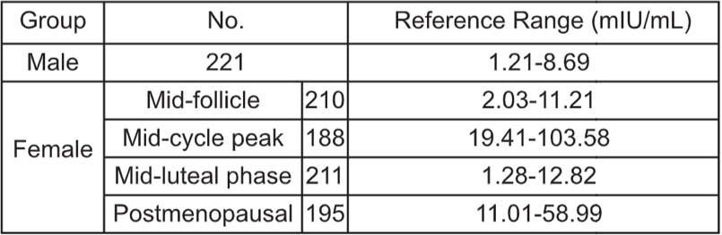
FSH reference range：
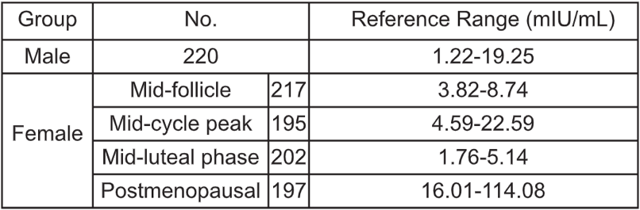
AMH reference range：
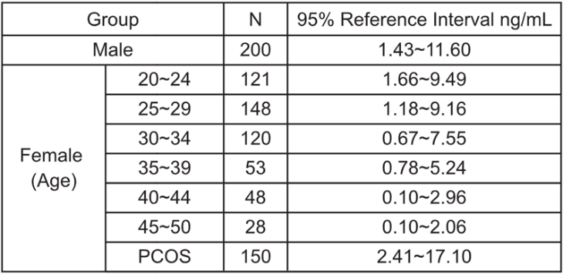
PRL reference range：
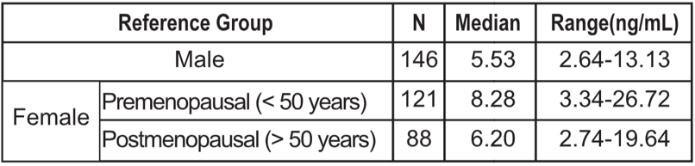
Prog reference range：
